SQL create and drop user
# Source: AI Source: Provided by: [Data Path: Persons Table -> ID Column: 1, Name_En Column: Motasem Essam] -> From: [ChatGPT] on [6/11/2026]
Here’s how you can create and drop a user in MySQL:

✅ 1. Create a User
# Source: AI Source: Provided by: [Data Path: Persons Table -> ID Column: 1, Name_En Column: Motasem Essam] -> From: [ChatGPT] on [6/11/2026]
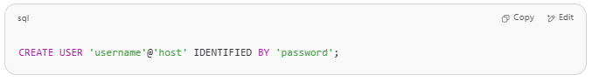
CREATE USER 'username'@'host' IDENTIFIED BY 'password';

🔧 Example:
# Source: AI Source: Provided by: [Data Path: Persons Table -> ID Column: 1, Name_En Column: Motasem Essam] -> From: [ChatGPT] on [6/11/2026]
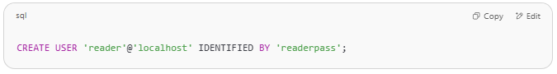
CREATE USER 'reader'@'localhost' IDENTIFIED BY 'readerpass';

- 'reader' is the username.
- 'localhost' means the user can connect only from the local server.
- 'readerpass' is the password.
You can verify with:
SELECT user, host FROM mysql.user WHERE user = 'reader';

If error
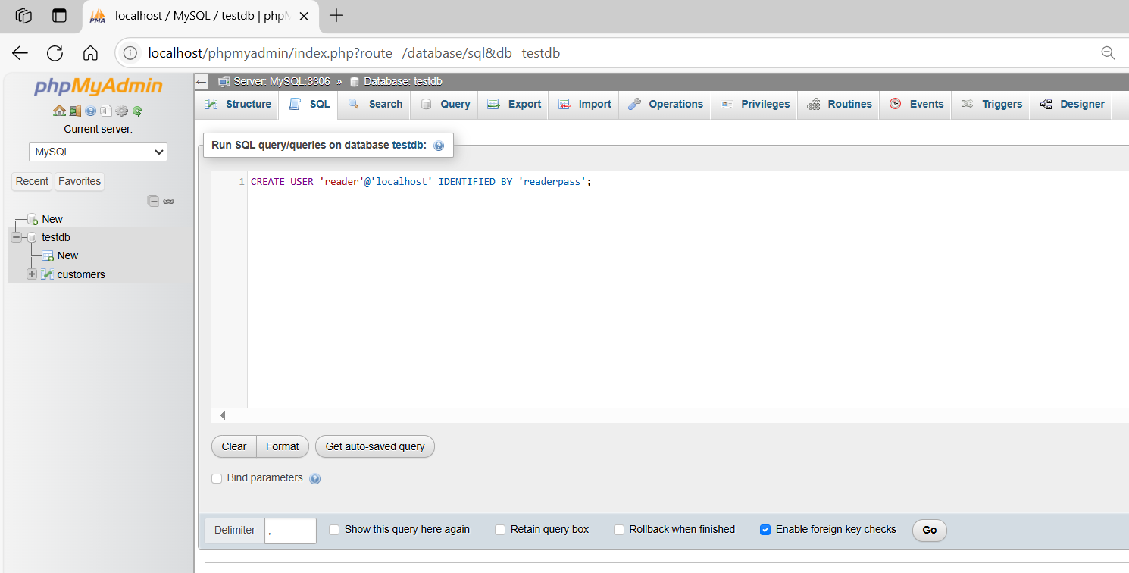
CREATE USER 'reader'@'localhost' IDENTIFIED BY 'readerpass';
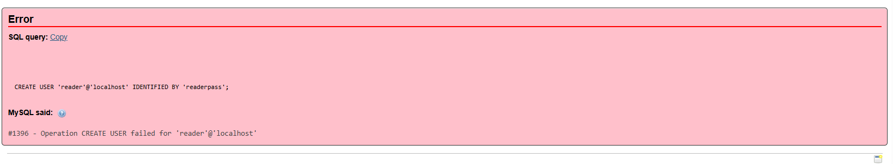

The error you're seeing:
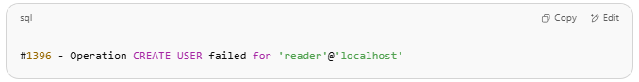
#1396 - Operation CREATE USER failed for 'reader'@'localhost'

means you don't have the necessary privileges to create a user in MySQL.

🔍 Common Causes
- You're not logged in as a user with CREATE USER privilege.
  - Typically, only root or an administrative user can run CREATE USER.
- User already exists.
  - If the user 'reader'@'localhost' already exists, CREATE USER will fail.
  - Use DROP USER 'reader'@'localhost'; first or use CREATE OR REPLACE USER.

✅ How to Check If User Exists
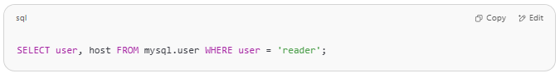
SELECT user, host FROM mysql.user WHERE user = 'reader';

✅ Fix Options

✔️ Option 1: If user already exists
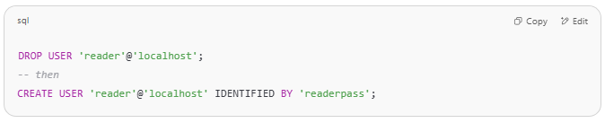
DROP USER 'reader'@'localhost';
-- then
CREATE USER 'reader'@'localhost' IDENTIFIED BY 'readerpass';

✔️ Option 2: Use CREATE OR REPLACE (MySQL 8+)
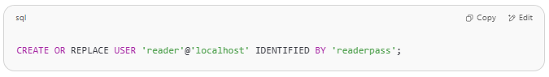
CREATE OR REPLACE USER 'reader'@'localhost' IDENTIFIED BY 'readerpass';

✔️ Option 3: Log in as root
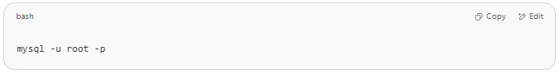
Make sure you're connected as:
mysql -u root -p

Then rerun:
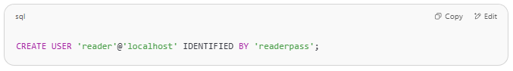
CREATE USER 'reader'@'localhost' IDENTIFIED BY 'readerpass';

Example

basic command
# Source: ScreenShot Source: Provided by: [Persons Table -> ID Column: 1, Name_En Column: Motasem Essam] -> Tool: [Automation Table -> ID Column: 16, Name_En Column: Screen Capture] -> From [Operating System: Wampserver64 -> phpmyadmin] on [6/11/2026]
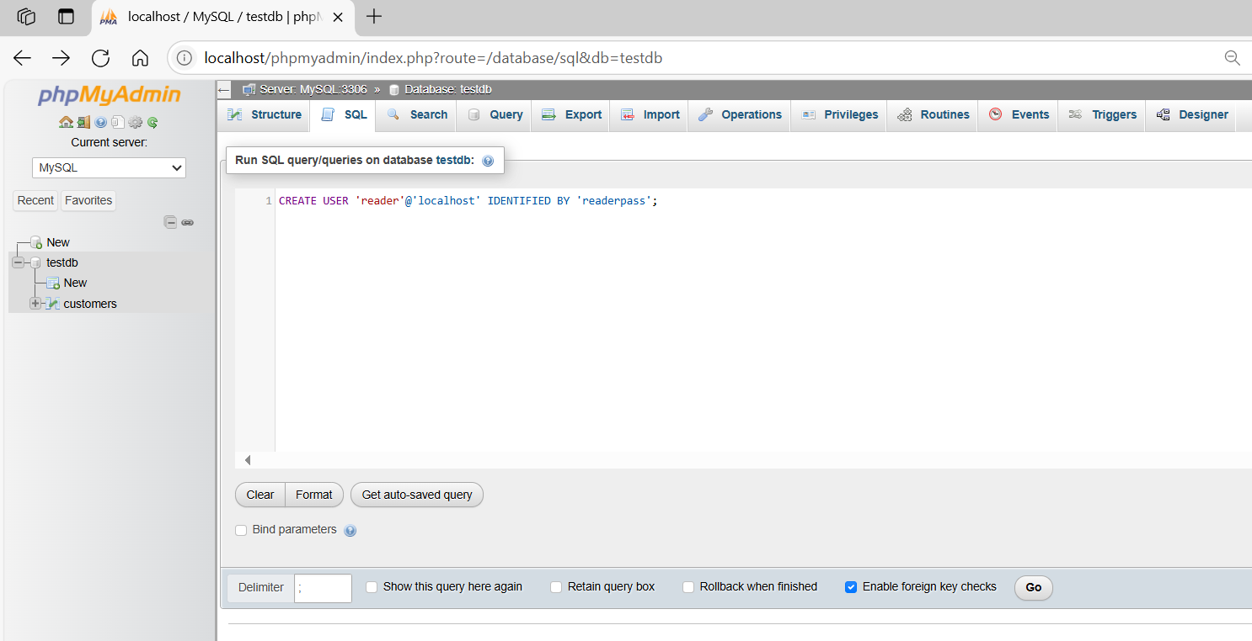
CREATE USER 'reader'@'localhost' IDENTIFIED BY 'readerpass';
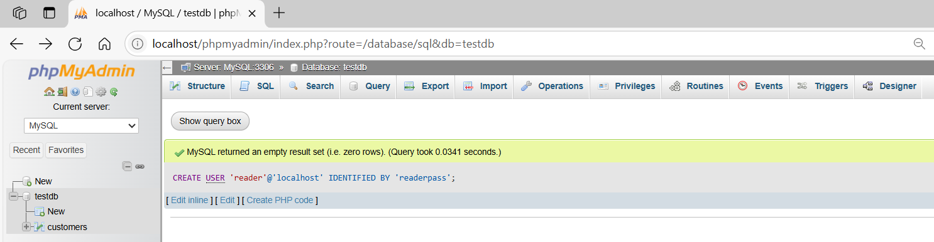

2. show User
To show users in MySQL, you can query the mysql.user table, which stores all user accounts.

✅ 1. List All Users
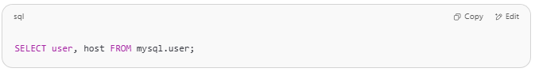
SELECT user, host FROM mysql.user;

This will return all users and the hosts they are allowed to connect from.

✅ 2. List Unique Usernames (simplified)
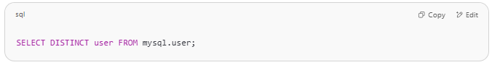
SELECT DISTINCT user FROM mysql.user;

This shows only unique usernames (regardless of host).

✅ 3. Show Grants (Privileges) for a Specific User
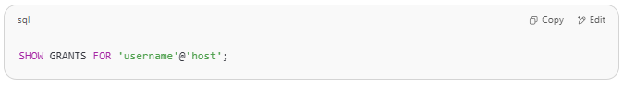
SHOW GRANTS FOR 'username'@'host';

Example:
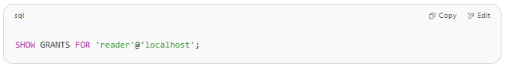
SHOW GRANTS FOR 'reader'@'localhost';

🔐 Permissions Required
You must have sufficient privileges (usually as root or an admin) to run these queries on the mysql system database.

Would you like a script that shows users and automatically generates the SHOW GRANTS commands for each one?

Example

basic command
# Source: ScreenShot Source: Provided by: [Persons Table -> ID Column: 1, Name_En Column: Motasem Essam] -> Tool: [Automation Table -> ID Column: 16, Name_En Column: Screen Capture] -> From [Operating System: Wampserver64 -> phpmyadmin] on [6/11/2026]
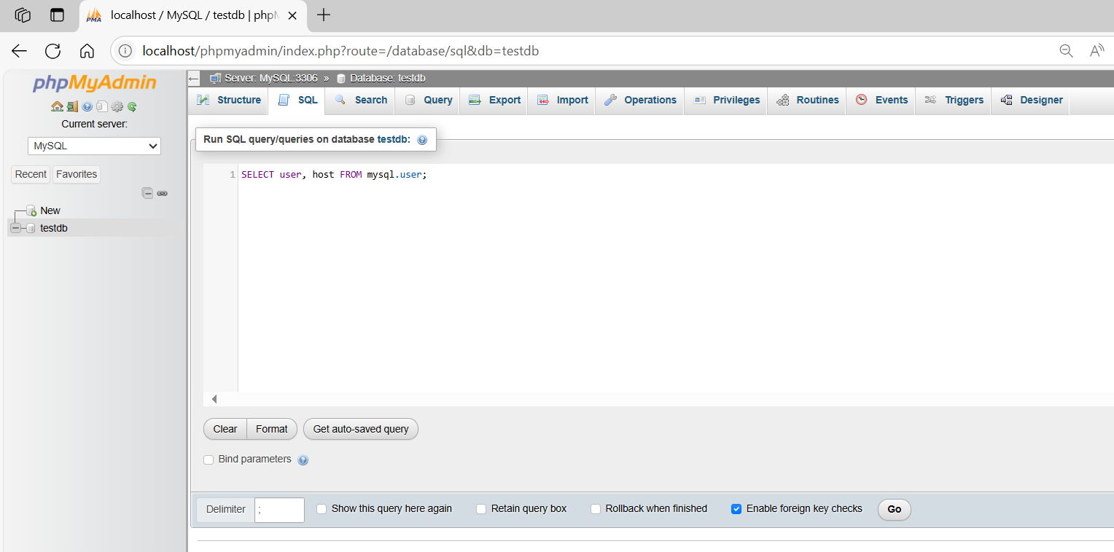
SELECT user, host FROM mysql.user;
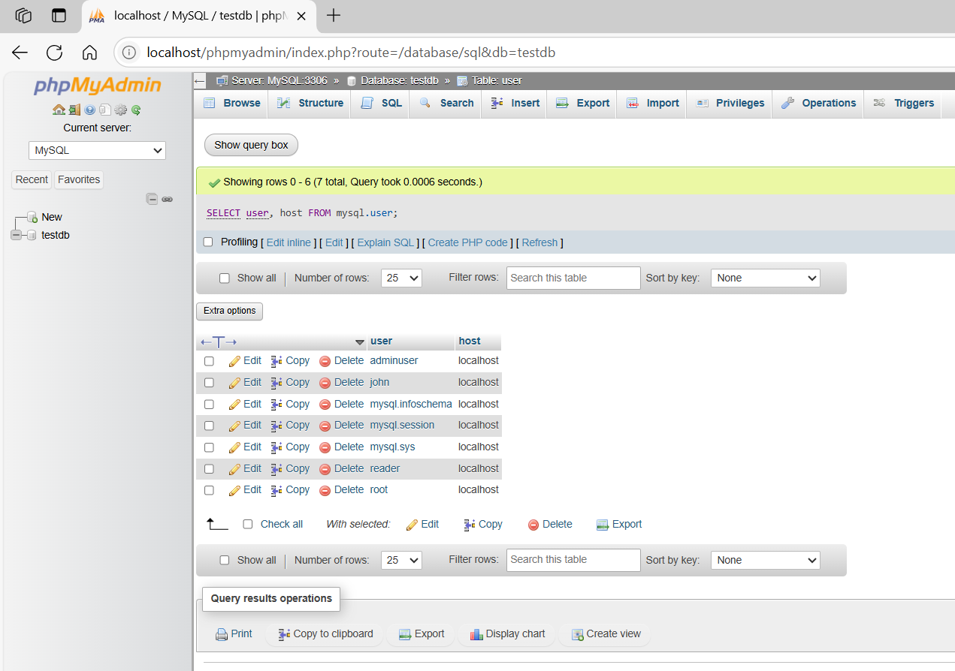

basic command
# Source: ScreenShot Source: Provided by: [Persons Table -> ID Column: 1, Name_En Column: Motasem Essam] -> Tool: [Automation Table -> ID Column: 16, Name_En Column: Screen Capture] -> From [Operating System: Wampserver64 -> phpmyadmin] on [6/11/2026]
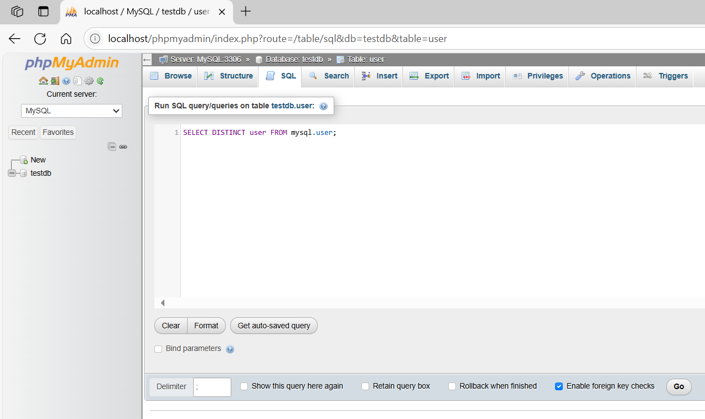
SELECT DISTINCT user FROM mysql.user;
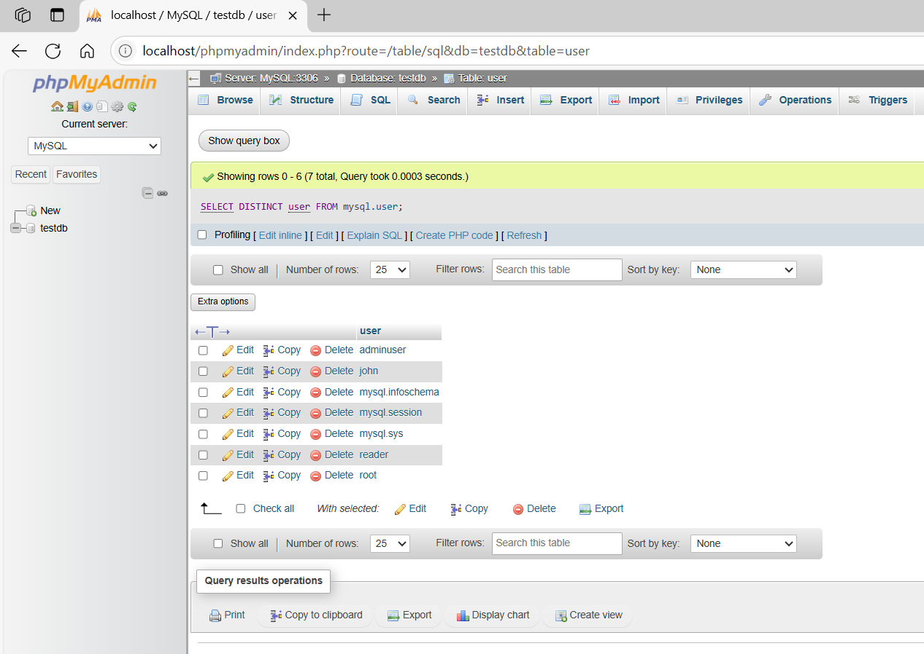

basic command
# Source: ScreenShot Source: Provided by: [Persons Table -> ID Column: 1, Name_En Column: Motasem Essam] -> Tool: [Automation Table -> ID Column: 16, Name_En Column: Screen Capture] -> From [Operating System: Wampserver64 -> phpmyadmin] on [6/11/2026]
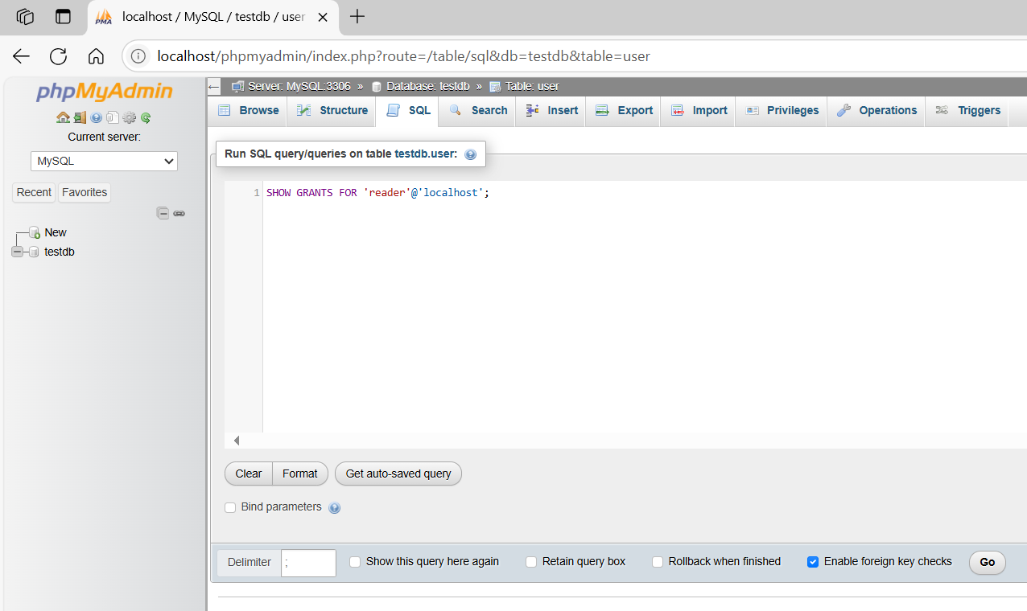
SHOW GRANTS FOR 'reader'@'localhost';
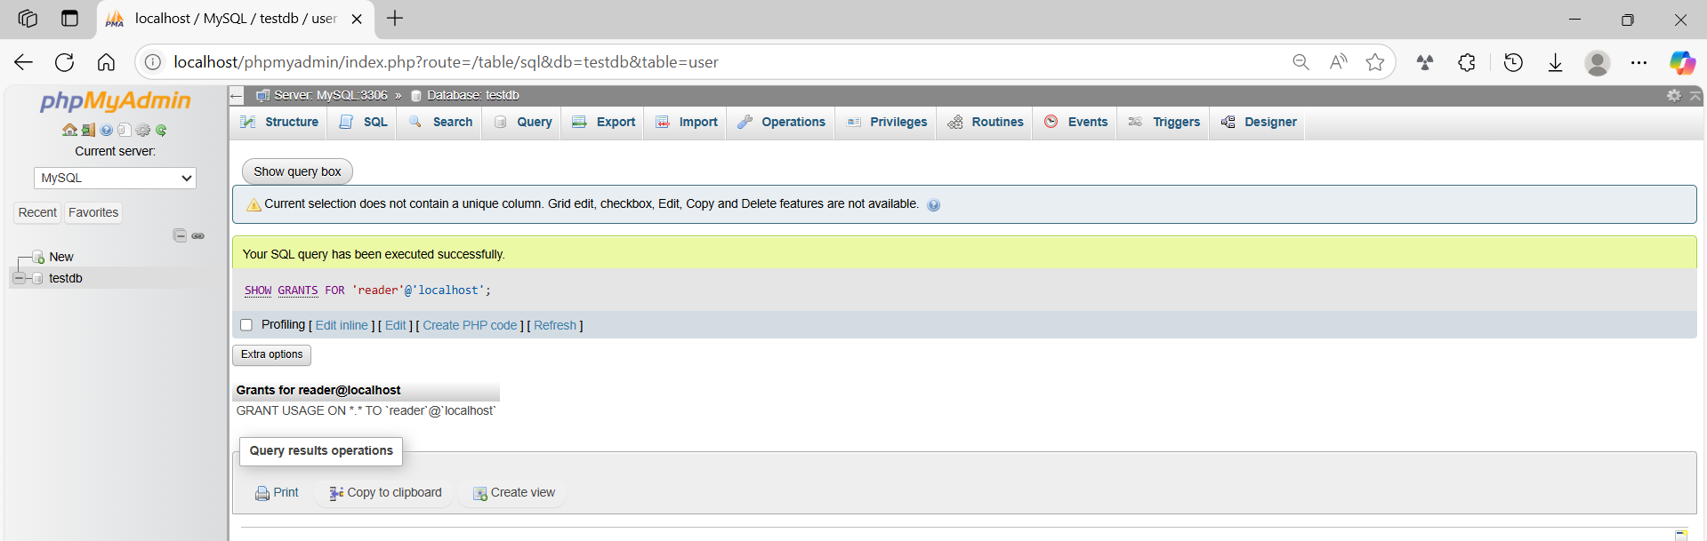

❌ 3. Drop (Delete) a User
# Source: AI Source: Provided by: [Data Path: Persons Table -> ID Column: 1, Name_En Column: Motasem Essam] -> From: [ChatGPT] on [6/11/2026]
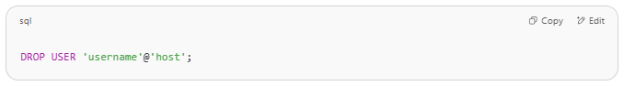
DROP USER 'username'@'host';

🔧 Example:
# Source: AI Source: Provided by: [Data Path: Persons Table -> ID Column: 1, Name_En Column: Motasem Essam] -> From: [ChatGPT] on [6/11/2026]
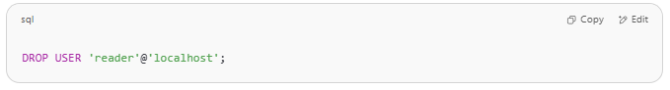
DROP USER 'reader'@'localhost';

This completely removes the user from the MySQL server.

Example

prepared commands
# Source: ScreenShot Source: Provided by: [Persons Table -> ID Column: 1, Name_En Column: Motasem Essam] -> Tool: [Automation Table -> ID Column: 16, Name_En Column: Screen Capture] -> From [Operating System: Wampserver64 -> phpmyadmin] on [6/11/2026]

CREATE USER 'reader'@'localhost' IDENTIFIED BY 'readerpass';


basic command
# Source: ScreenShot Source: Provided by: [Persons Table -> ID Column: 1, Name_En Column: Motasem Essam] -> Tool: [Automation Table -> ID Column: 16, Name_En Column: Screen Capture] -> From [Operating System: Wampserver64 -> phpmyadmin] on [6/11/2026]
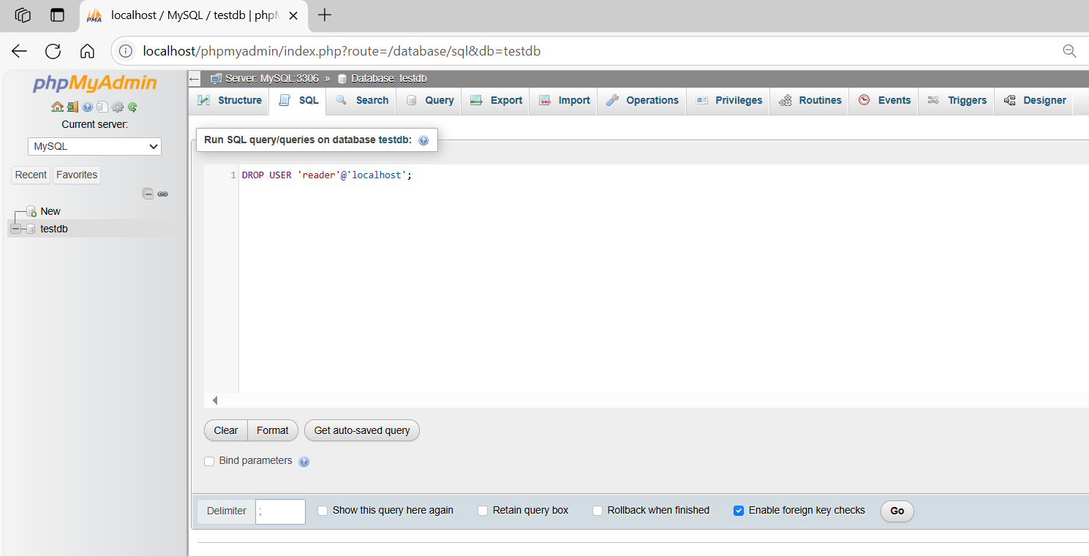
DROP USER 'reader'@'localhost';
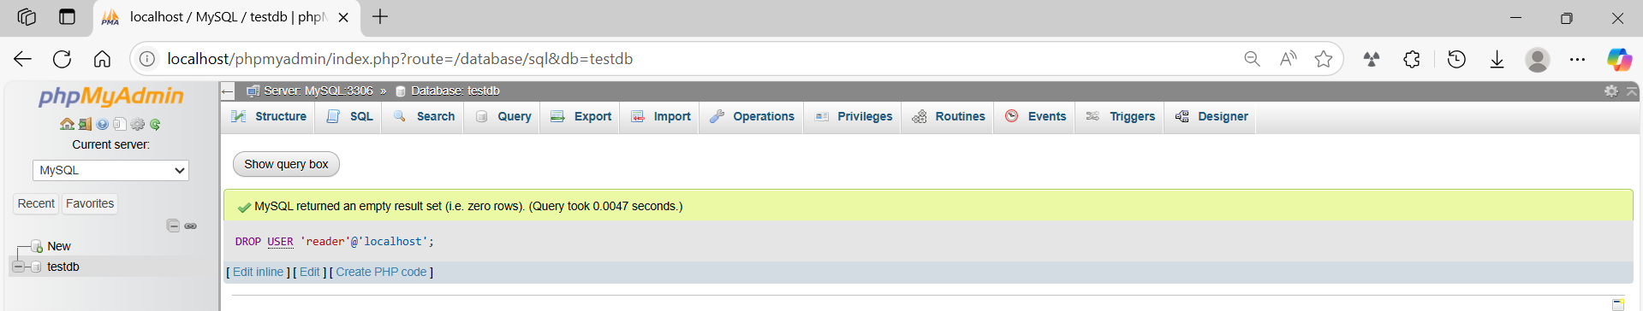
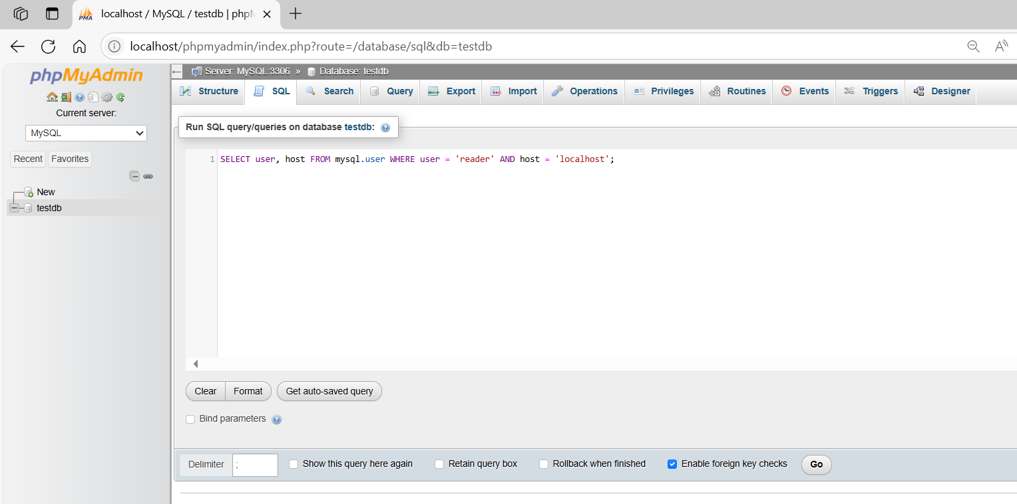
SELECT user, host FROM mysql.user WHERE user = 'reader' AND host = 'localhost';
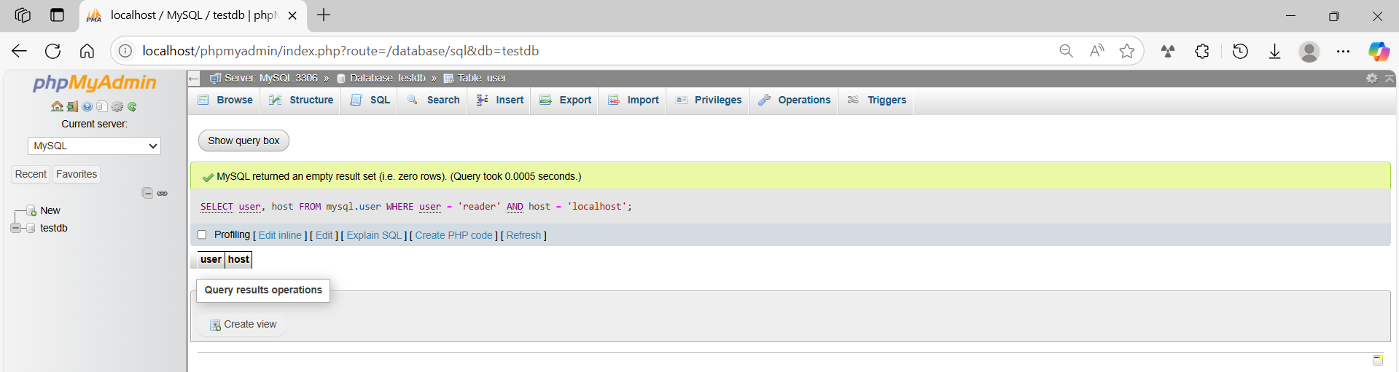

🚨 Notes:
# Source: AI Source: Provided by: [Data Path: Persons Table -> ID Column: 1, Name_En Column: Motasem Essam] -> From: [ChatGPT] on [6/11/2026]
- You must be logged in as a user with CREATE USER and DROP USER privileges (typically root).
- MySQL 8+ does not allow creating users via GRANT anymore — use CREATE USER first, then GRANT.

